**Companion for Zeo   
Users Guide**

**Version 1.1.0**

This User’s Guide is dedicated to the Public Domain.

The terms “Zeo” , “Zeo Professional Sleep Manager”, “Zeo Headband”, “Zeo Application”, “Zeo App” and “Zeo API” refer to hardware products, copyrighted software and documentation, and direct copyrights of Zeo, Inc (defunct) and its successors and assignees: https://en.wikipedia.org/wiki/Zeo,\_Inc.

The term “Zeo Data Viewer” refers to presumed copyrighted software owned and maintained by AlienRat Design: <http://www.alienrat.net/software/zeomonitor.html>

The term “Sleepyhead” refers to copyrighted software owned and maintained by Mark Watkins:  
<https://sleepyhead.jedimark.net/>

Table of Contents

[Introduction 1](#_Toc453604227)

[Android Permissions 1](#_Toc453604228)

[Privacy for your Zeo Data 1](#_Toc453604229)

[Choose how you want to use the App 2](#_Toc453604230)

[Section I. Sleep Session History 3](#_Toc453604231)

[Hidden Sleep Results 3](#_Toc453604232)

[Amended Sleep Results 3](#_Toc453604233)

[History Tab 4](#_Toc453604234)

[History Details – Using the Zeo App only 6](#_Toc453604235)

[History Details – Integrated use of Sleep Journal 8](#_Toc453604236)

[History Details – Amended Sleep Records 9](#_Toc453604237)

[Section II. Sleep Journal 12](#_Toc453604238)

[Sleep Journal’s Utility 12](#_Toc453604239)

[Sleep Journal Layout 13](#_Toc453604240)

[Typical Sleep Journal Use 14](#_Toc453604241)

[Dealing with Occasional Sleep Journal Issues 16](#_Toc453604242)

[Section III. Sleep Analysis 17](#_Toc453604243)

[Parameters Available For Analysis 17](#_Toc453604244)

[Trends Chart 18](#_Toc453604245)

[Attribute Effects Chart 21](#_Toc453604246)

[Section IV. Exporting and Sharing 22](#_Toc453604247)

[Formats of Exportable Information 22](#_Toc453604248)

[Image Export Example 23](#_Toc453604249)

[Modes of Export 23](#_Toc453604250)

[Export Invocation 23](#_Toc453604251)

[Export Example 24](#_Toc453604252)

[Direct Email Outbox (Manual or Automated exporting) 25](#_Toc453604253)

[Expanded myZeo+ CSV file 26](#_Toc453604254)

[Section V. Customization and Settings 32](#_Toc453604255)

[Customization 32](#_Toc453604256)

[Customize Attributes and Values 32](#_Toc453604257)

[Customize Doing Events 37](#_Toc453604258)

[Customize the Order of Prior-to-Sleep Attributes 38](#_Toc453604259)

[Restore Factory Defaults 38](#_Toc453604260)

[Settings 39](#_Toc453604261)

[Section VI. Extras 45](#_Toc453604262)

[ZeoCompanion DB Backup 45](#_Toc453604263)

[ZeoCompanion DB Restore 45](#_Toc453604264)

[ZeoCompanion Alerts 46](#_Toc453604265)

[ZeoCompanion Error Log file 46](#_Toc453604266)

[Headband Commander 47](#_Toc453604267)

# Introduction

When the Zeo Corporation went out of business in 2013, that left users of the Zeo Professional Sleep Manager without the extended features offered by Zeo’s web site, including exporting of end-user’s data. However, the baseline Zeo Headbands and the Zeo Android App continue to remain useful even until today (2016). Recently, over 2,600 Zeo Pros were purchase by end-users from a discounter due to the recommendation of Steve Gibson from his “Security Now” podcast.

This ZeoCompanion App compliments the Zeo Android App, utilizing its published and public API, to offer those extended capabilities that the Zeo website offered but are now lost. These capabilities include data export to personal computers, sleep journal to augment the headband’s recordings, and sleep results trend displays.

# Android Permissions

In order for this App to function properly, it must have certain permissions granted. Before Android Marshmallow (6.0), these were granted in-bulk at installation. In Android Marshmallow (6.0) and beyond, these permissions are explicitly and individually asked for and granted after you fist use the App. The following table lists the permissions needed, why, and when they will be asked for.

|  |  |  |
| --- | --- | --- |
| **Permission** | **Why** | **When asked for** |
| **Write External Storage** | Store exports, database backups, and error logs | Every App startup until granted |
| **Zeo Read Sleep Records** | Read the Zeo App’s database | Every App startup until granted |
| **Internet** | Send Direct Emails of exports | If Direct Email is enabled, then every App startup until granted |
| **Bluetooth and  Bluetooth Admin** | Access to the Zeo Headband | Only if the Headband Commander is invoked |

# Privacy for your Zeo Data

Even though the company Zeo Inc went out of business in 2013, their former web site myzeo.com still remains active by an unknown owner and still accepts Zeo data. If you do not configure an email address in the Zeo App’s “Connect to myZeo” menu item, then for the most part, the Zeo Android App will make no contact with the “dark hole” myzeo.com web site. If there is anything in the email field, the Zeo App will send your sleep data to the “dark hole” myzeo.com web site even though it no longer has end-user login accounts.

However, the Zeo App WILL contact “http://mysleep.myzeo.com/debugMessage.cfm?...” every 24 hours, and send some headband specific information, including the headband’s serial number, Bluetooth address, and generic usage information. If this causes you concern, your only option is to attempt to block the “mysleep.myzeo.com” domain in your firewall/router.

# Choose how you want to use the App

This App provides three main capabilities to expand upon the limited features the baseline Zeo App provides: export, backup, and sleep journal. You choose which or all of those three you want to use:

C

A

B

* If all you want to do is export and backup, use the drop-down menu (**C**) to open Settings-> Journal to turn off “Enable Journal”. The App’s screen will simplify to just two tabs:
  + Use the Share/Export button (**A**) for exporting of Zeo App data. See Section III.
  + To backup the Zeo App database, first go to Settings->Database and turn on Zeo App replication. Then use the Backup button (**B**) to create a backup. See Section V.
* If you want automatic daily emailed exports, use the Settings->Email and   
  Settings-> Auto-Email screens to set that up.
* If you just want to record some supplements and before-sleep attributes that will export with your Zeo Data, use the Settings->Journal to turn off “Enable In-Bed”, “Enable Going”, “Enable During” and “Enable After” tabs. You can also customize those before-sleep attributes using the “Customize Attributes” menu item. See Sections II and IV.
* If you want to amend the Zeo data because it improperly records times you are awake as sleep, use the Settings->Journal to leave on the “Enable In-Bed”, “Enable Going”, “Enable During”, and “Enable After” tabs. See Section II.

# Section I. Sleep Session History

The ZeoCompanion accesses the Zeo App’s database through its published and public API to extract your sleep session records. Thus as a baseline, the ZeoCompanion App has access to the same data as the Zeo App, and can provide export and limited analysis features that the Zeo App lacks.

## Hidden Sleep Results

The Zeo App automatically hides from its History list all completed sleep sessions that resulted in zero (0.0) total sleep time (the time in Deep + time in Light + time in REM = 0). If you are NOT using the Sleep Journal feature (Section II), then the ZeoCompanion App will similarly hide these completed “zero sleep” sessions from its History Tab, even one that just completed.

If you do use the Sleep Journal to record attributes or events into a sleep session that ultimately results in “zero sleep”, that sleep session will NOT show on the Zeo App History list, but WILL show on the ZeoCompanion History Tab. However, its Zeo App data will be stated as “Missing”. If you do not want the “partially hidden” ZeoCompanion record to be retained, just use the “Delete” icon on the History Details screen for the “partially hidden” sleep record, and just the ZeoCompanion data will be deleted and no longer show on the History Tab.

## Amended Sleep Results

Although the Zeo Pro Sleep Manager does a good job at sleep analysis for people with “normal sleep” patterns, it actually was not vetted nor verified for use by persons with sleep issues. Thus the Zeo Headband has particular trouble determining whether someone is motionless in-bed yet awake, or motionless in-bed and asleep. This is particular vexing for those people who use the Zeo Pro Sleep Manager, yet have “cannot fall asleep” issues, or “constantly wake up in the middle of the night” sleep issues.

The Sleep Journal described in Section II was designed to address these issues, and compliment the Zeo Headband’s analytics with information from the sleeper. Thus if you choose to utilize the event buttons on the Sleep Journal’s *In-bed*, *Going to Sleep*, or *During Sleep* tabs, the Sleep Journal will automatically create an Amended Sleep Record. This amended record is parallel to the Zeo App’s sleep record; both are maintained and both are always viewable. The Sleep Journal does not and cannot alter the Zeo App’s stored information.

On the *History* Tab and the *History Detail* screens described in the next section, if an amended sleep record is available, there will be differences to the on-screen displays that will provide you significantly more information, and means to switch back-and-forth between the baseline Zeo App sleep record and the ZeoCompanion amended sleep record. You also have similar choices when exporting or sharing sleep records as described in Section III.

## History Tab

The *History* tab shows a summation of each of your recorded sleep sessions (be they Zeo App only, or integrated with the Sleep Journal). This display is similar to the Zeo App’s own History Tab display.

A

B

C

If you press on a row, it will automatically invoke a History Details screen for the sleep record of that date.

**A:** The starting date and time of the sleep session, the resultant ZQ score, and the every 5-minute “display” hypnogram are shown. Red bars are awake time, Green bars are REM sleep, Light blue are Light sleep, and Dark blue are Deep sleep.

**B:** An optional summary of key sleep parameters that directly calculate the ZQ score. Use the Settings->History menu to remove it if desired. Text in Green means that row met your goals. Yellow means within 25% of the goal. Red means below 25% of the goal (or in cases of #Awakens or Awake time always Red since it’s always bad).

**C:** The Show Amended checkbox allows you to toggle the graphs between the baseline Zeo App sleep results, and the amended results based upon the extra Sleep Journal information. This checkbox will only be present if you have sleep records that do have amendments. You can use the Settings->Journal Amend menu to have this checked by default if you always want to see the amended results first.

**Showing Amended Sleep Results**



B

A

**A:** *Changes*: Note the additional “Awake” time intervals that the Sleep Journal inserted (as recorded by direct end-user input) compared to the prior screenshot.

**B:** *Changes*: Note that the key parameters have changed and worsened according to this amended sleep record.

## History Details – Using the Zeo App only

The History Details screen shows just one sleep session, and includes integrated data from the Zeo App and from the ZeoCompanion App databases. The baseline details display is shown if the Sleep Journal features of this App have not been used.

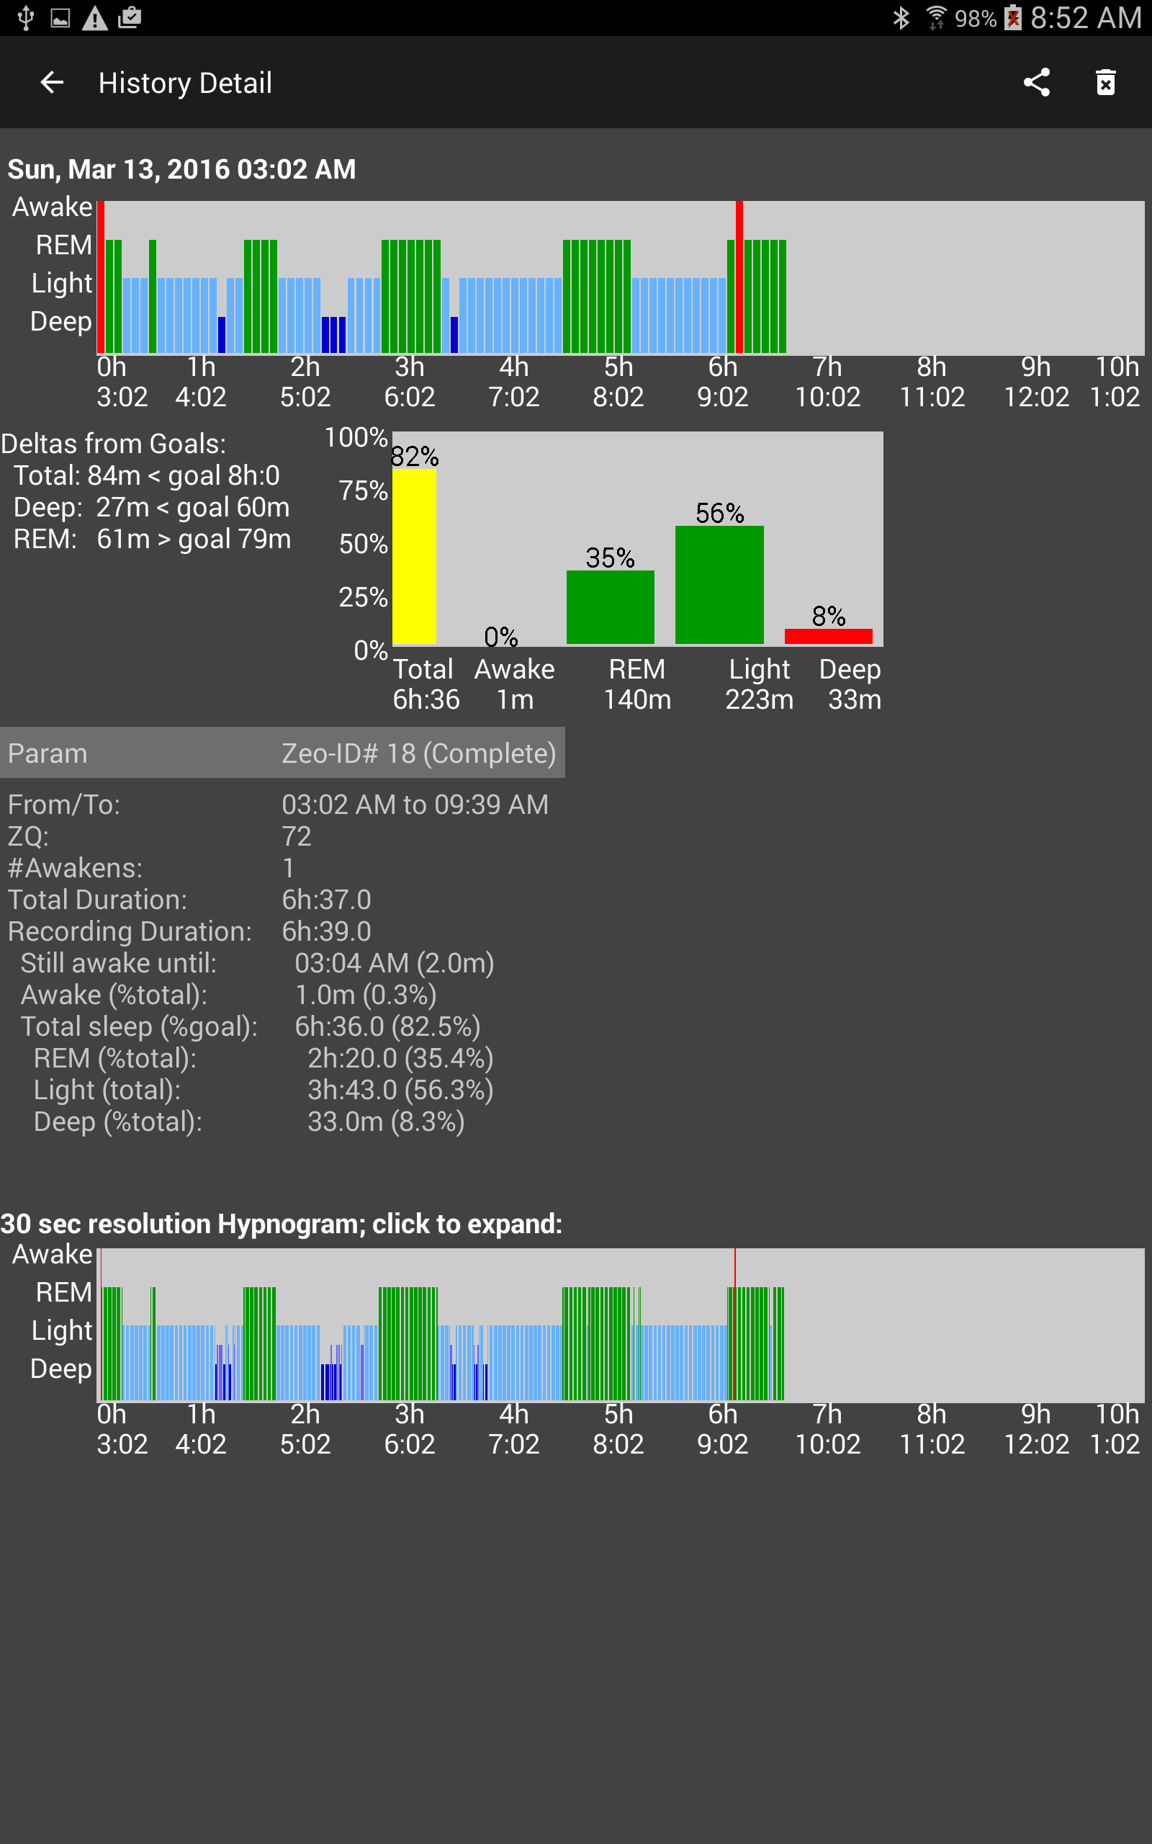

D

C

E

A

B

**A:** This date and hypnogram is the same as was shown on the History Tab, though the hypnogram is larger and has axis labels. Informational or warning messages may also be shown here.

**B:** This is a textual and graphical summary of your sleep session. The amount of total, deep, and REM sleep are compared to your goals. The graph shows the breakdown of the sleep stages in percent. The Awake, REM, Light, and Deep are all percentages of Total Sleep. The Total sleep is percentage of goal (typically 8 hours which is configurable in the Settings->Profile). The color code is: Green bars mean met your goals. Yellow bars mean within 25% of the goal. Red bars mean below 25% of the goal (or in the case of Awake time always Red since it is always bad).

**C:** These are the textual details of the sleep session from the Zeo App’s database. The Total Duration is based upon the From/To times. The Recording Duration includes only time intervals the Headband was actually able to take a reading. The Zeo headband reports a “Battery” value, however there is no documentation as to what the value means. However if this number starts significantly reducing in value over time, it may indicate the headband’s battery is starting to go bad.

**D:** This is the detailed hypnogram, scaled as same as the every 5-minute hypnogram. Depending on your screen size, it will be 30-sec, 60-sec, or 90-sec per bar. You will likely notice many differences between the upper and lower hypnograms where the Zeo Headband “averaged” the results for the upper 5-minute hypnogram and lost detail. You can click on this hypnogram, and a larger scrollable and zoomable 30-second per bar version will appear in a popup window (see below).

**E:** The Share button will allow you to export or share just this record; see the Exporting and Sharing section. The Delete button will allow you to delete ONLY the ZeoCompanion portion of this sleep record in case it is wrong, incomplete, or mis-started. The ZeoCompanion cannot delete any records stored in the Zeo App itself.

The popup 30-second hypnogram is shown below. You can finger scroll it right and left. You can use a two finger “pinch” gesture to expand or contract it. And you can set the initial span of time shown in the Settings->History.



## History Details – Integrated use of Sleep Journal

The history details display shows more integrated information if the various features of the Sleep Journal are actively used. The enhanced features include annotated hypnograms, amended sleep records including side-by-side comparison, amended hypnograms, and sleep journal history.

## G:\Development\Mobile\Android\ZeoMobile\ZeoCompanion\Resources\Users Guide\ScreenShots\Screenshot_2016-04-15-08-52-28.png

G

D

C

B

A

E

F

**A:** *Additions*: The hypnogram is annotated with any events you may have entered via the Sleep Journal overnight. The codes are: **T**=In-bed tab Trying-to-sleep button, **S**=Going-to-sleep tab Still-awake button, **W**=While-sleep tab Woke-up button, **D**=While-sleep tab Did-something dropdown, **R**=While-sleep tab Retrying-to-sleep button.

**B:** *Additions*: the Sleep results from the After-sleep tab are also shown

**C:** *Additions*: the textual details of the sleep session from the ZeoCompanion App’s database are also shown. Note that the Recording Duration is shorter than the Total Duration due to the gap toward the ends of the hypnograms where the Headband failed to record. If the Sleep Journal was able to create an amended sleep record, all the matching amended details are shown side-by-side with the Zeo’s baseline data. If the Sleep Journal could not or did not amend the sleep record, then only a limited few data rows will be shown. The “red-ish” highlight indicates that the baseline Zeo App data is showing on the various graphs.

**D:** *Additions*: the hypnogram is annotated in the same manner with the same codes as ‘A’.

**E:** (no changes)

**F:** *New*: the Show Amended checkbox allows you to toggle the graphs between the baseline Zeo App sleep results, and the amended results based upon the extra Sleep Journal information (see next section). You can also press the two “cells” (the left-most currently has red-ish highlight) to toggle as well.

**G:** *New*: the complete attributes and events record from the Sleep Journal are shown.

The popup 30-second hypnogram also includes the annotations as shown below.



## History Details – Amended Sleep Records

As discussed at the introduction to this section, at times and for some people’s sleep issues, the Zeo Headband significantly over-estimates the amount of sleep actually achieved. By using the event recording capabilities of the Sleep Journal, times that you are truly awake can be notated even though the Zeo Headband records REM and Light sleep. The Sleep Journal can then create a secondary amended set of hypnograms and data that show the awake times that you have indicated, and a re-calculated ZQ score. Realistically this amending creates a “best case” and “worst case” of your sleep results and ZQ scores. Somewhere between these two points was your actual sleep experience.

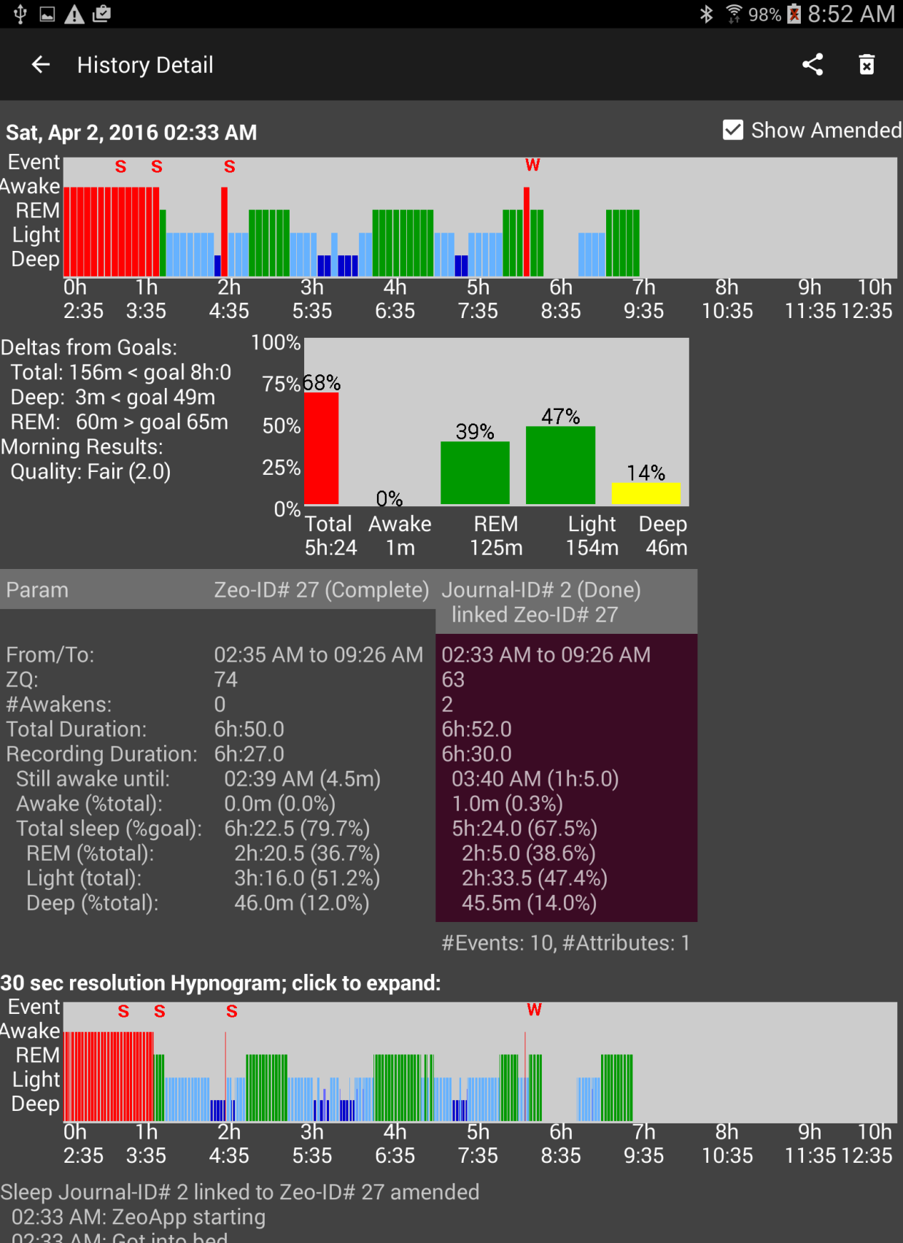

B

C

A

**A:** *Amendments*: Note the additional “awake” bars at the beginning of the sleep session where “still awake” events were recorded. Also note the additional “awake bars” where the third “still awake” event occurred, and the “woke-up” event occurred. The 30-sec detailed hypnogram has the same amendments.

**B:** *Amendments*: the text details and the graph have changed (and worsened) due to the additional Sleep Journal information about still-awake interval.

**C:** *Amendments*: notice the “second cell” now has the “red-ish” highlight since the amended results are showing. Also notice the total sleep time has been reduced, and the amount of Light and REM sleep has been reduced. The ZQ score dropped from 74 to 66.

The amended popup 30-second hypnogram also shows in more detail the amendments. For those that have “cannot-fall-asleep” sleep issues, the perception of time becomes distorted. A person may drift in-and-out of sleep with a continuity of thoughts and dreams. So the “still-awake” feature does not “backtrack” past a deep sleep interval.



A

# Section II. Sleep Journal

The Sleep Journal feature of the ZeoCompanion is meant to be used in conjunction with the Zeo Pro Sleep Manager’s Android application. It is **NOT** designed to be a stand-alone sleep journal, and provides only limited information and analysis when used stand-alone.

The Sleep Journal feature is also optional. One does not have to use it at all, and it can be turned fully off using Settings->History. Or specific journal tabs that you do not want to utilize can be individually turned off in Settings->Journal.

The Sleep Journal‘s prior-to-sleep and after-sleep attributes and values are customizable. You can hide attributes that are not useful to your sleep issues. You can add new attributes that are useful. You can change the order in which the attributes are shown. You can add, delete, and change the values that are selectable for each attribute. These capabilities are available in the menu under Customization.

Usage hint: you can use a swipe gesture to flip between tabs in addition to pressing a tab button.

## Sleep Journal’s Utility

For those with no sleep issues, the Sleep Journal feature provides little additional benefit beyond the Zeo Application’s own capabilities. However for those with sleep issues, the Sleep Journal can be used to augment the Zeo Application’s capabilities with your own experiments with supplements and sleep techniques by examining “inputs” (supplements, environment, techniques) and “outputs” (how well did you sleep).

The Sleep Journal offers specific features for specific sleep issues:

1. For all sleep issues, you can record what sleep-enhancing supplements you took prior to bed, and record information about your mood and sleep environment. These can be compared with your sleep results, and over a period of time you may be able to determine causes and effects that lead to better sleep.
2. For those that find it hard to fall asleep, and the Zeo Headband records you are asleep while are actually awake, you can record your “still awake” condition and optionally have the ZeoCompanion amend the Zeo App’s data to reflect your real sleep experience.
3. For those that consistently wake up one or more times at night, the “during sleep” feature can record when you woke up, what you did (if anything), and when you re-attempted to fall asleep.

As mentioned in Section I, the Sleep Journal offers the **optional** capability to amend the Zeo Application’s sleep data so it better reflects your issues with falling asleep or staying asleep. The ZeoCompanion cannot and does not alter the Zeo Application’s own database. All the optional feature does is provide a “second view” into the sleep records, and additional information in the exports.

## Sleep Journal Layout

The ZeoCompanion Sleep Journal feature has the following elements on the Android device:



F

D

E

A

B

C

**A:** The following Tabs are for the Sleep Journal feature: *Prior to Bed, In Bed, Going to Sleep, During Sleep, After Sleep, Journal Summary*. You can either press a tab button, or you can swipe left or swipe right.

**B:** The deep purple bar is the Journal Status Bar (JSB). In the middle it shows the status of the Zeo Application, the ZeoCompanion Application, and the overall Sleep Journal state. When ready for recording, it should show “Tonight” as overall status, “Idle” for the Zeo App status, and “None” for the ZeoCompanion App status. The two “LEDs” are described in the table below.

|  |  |  |
| --- | --- | --- |
| **LED color** | **Zeo App status** | **Sleep Journal status** |
| Gray | Idle; a *pulse* indicates a probe of the Zeo App | Idle |
| Green | Recording; a *pulse* indicates a probe of the Zeo App | Recording |
| Red | *Blinking:* Zeo Headband is not recording when it should | (not used) |

**C:** Also part of the JSB, this shows the last-most recent sleep session (if any), and the LAST button. Pressing the LAST button will shift the Sleep Journal into limited editing mode for the prior sleep session. Pressing the LAST button will shift the Sleep Journal backward from Next to Tonight to Prior.

**D:** Also part of the JSB, this normally is blank. Pressing the NEXT button (if visible) will shift the Sleep Journal forward from Prior to Tonight.

**E:** The body of each Sleep Journal tab. Clickable “data entry” buttons and lists have the bright blue background or text color.

**F:** For the *In-Bed* and *After Sleep* tabs, the “Show hidden” checkbox will temporarily show all the normally hidden attributes in order to chose ones that are not often needed.

## Typical Sleep Journal Use

A typical scenario to fully utilize the Sleep Journal is shown in the table below.   
**Note: the ZeoCompanion App MUST be left active in the “foreground” of the Android Device all night for the Sleep Journal to function properly:**

| **Step** | **Description** | **JSB display** |
| --- | --- | --- |
| 1 | Before bed, the Journal Status Bar (JSB) should be showing the status seen to the right. If instead it is showing “Prior” press the NEXT button on the JSB. If it is showing “None” then press the LAST button. | G:\Development\Mobile\Android\ZeoMobile\ZeoCompanion\Resources\Users Guide\Cutouts\Journal_1.png |
| 2 | Just before bed, **go to the *Prior to Bed* tab**. Pick applicable values for the attributes that you wish to record for the night’s recording session. The JSB status will change as shown. To select an attribute’s value, press on the bright blue “-none-“ text. A list will popup with pre-defined values to choose from. Select a value and it will be recorded. Note that you can turn on the “Show hidden” checkbox to temporarily see all the attributes for rarely needed ones. | G:\Development\Mobile\Android\ZeoMobile\ZeoCompanion\Resources\Users Guide\Cutouts\Journal_2.png |
| 3 | If you planning on doing something in bed other than sleeping, on the *In-Bed* tab, you can indicate when you get physically GOT INTO BED using the button, and indicate when you are doing various activities in-bed other than sleeping. The JSB will remain as shown in step 2. The GOT INTO BED button should only be pressed once per sleep session. If you choose to wear your Zeo Headband during these non-sleep yet in-bed activities, steps 4 and 5 will occur too. |  |
| 4 | **Put on your Zeo Headband**. The Zeo Companion App should detect when the Zeo App has started within 15 to 30 seconds. The JSB will change again as shown. | G:\Development\Mobile\Android\ZeoMobile\ZeoCompanion\Resources\Users Guide\Cutouts\Journal_4.png |
| 5 | Once the Zeo App starts to officially record, the JSB will change as shown. Now every event that is entered on the *In-bed*, *Going to Sleep*, or *During Sleep* tabs will be associated with your combined Zeo App and ZeoCompanion App sleep session records. | G:\Development\Mobile\Android\ZeoMobile\ZeoCompanion\Resources\Users Guide\Cutouts\Journal_5.png |
| 6 | **Get into bed and prepare for sleep.** Press the NOW TRYING TO SLEEP button to indicate you are actually attempting to sleep. The NOW TRYING TO SLEEP button can only be pressed once per sleep session. **Leave the ZeoCompanion App running in the foreground of your Android device!** |  |
| 7 | If you are a “cannot fall asleep” type of insomniac, and have noticed the Zeo App’s headband actually does not properly detect you are still awake for hours on end, **you can used the *Going to Sleep* tab to document your wakefulness**. After 30 seconds the display will dim as much as the Android device will allow to not impede your sleep (but it will be visible to your darkness vision).  Leave the ***Going to Sleep* tab open.** While in bed attempting to sleep, you can periodically hit the **STILL AWAKE** button. These still-awake events will be recorded in the Sleep Journal. |  |
| 8 | If you are a “wakes up in the middle of the night” type of insomniac, **you can use the *During Sleep* tab to document your awakenings**. After 30 seconds the display will dim as much as the Android device will allow to not impede your sleep (but it will be visible to your darkness vision).  You can press the WOKE UP button to record an event that you indeed woke up. If you do activities like go to the bathroom, you can record these events too. Then you can press the RETRYING TO SLEEP button when you get back into bed. To get the best record of the awake interval, be sure to always pair a WOKE UP with a RETRYING TO SLEEP. Only a WOKE UP event is counted toward the Number of Awakenings.  Also, after a RETRYING TO SLEEP, you can use the step 7’s **STILL AWAKE** sleep journal feature.  Note that you need to leave your Zeo headband either on your head or at least not plugged into its charger. If you plug the Zeo headband into its charger when you wake up for an extended period overnight, that will close both the Zeo App’s sleep session as well as the ZeoCompanion App’s sleep session. |  |
| 9 | The next morning after you have finished sleeping and are going to get out of bed, **go to the *After Sleep* tab and press the DONE SLEEPING button**. The JSB will change as shown. The DONE SLEEPING button can only be pressed once per sleep session. | G:\Development\Mobile\Android\ZeoMobile\ZeoCompanion\Resources\Users Guide\Cutouts\Journal_9.png |
| 10 | **Take the Zeo headband off and plug it into its charger**. The JSB will change as shown. | G:\Development\Mobile\Android\ZeoMobile\ZeoCompanion\Resources\Users Guide\Cutouts\Journal_10.png |
| 10a | Note that you do not have to press the DONE SLEEPING button if you so desire. If you just take off the Zeo Headband without pressing the DONE SLEEPING button. |  |
| 11 | **Enter in any after-sleep attributes into the *After Sleep* tab**, and they will be recorded into that “Prior” entry. |  |
| 12 | **Go to the *Sleep Journal* tab** to see a list of all the attributes and events that occurred in that “Prior” entry. |  |
| 13 | Press the NEXT button and the Journal is ready for the next night’s sleep. LAST button and the “Prior” entry will be re-shown. |  |

## Dealing with Occasional Sleep Journal Issues

Occasionally when using the real-time Sleep Journal, the Zeo Headband and/or the Zeo App can get out-of-sync or move into states that are known but not typical. This section identifies some of those known but not typical situations.

**Headband goes Out-of-Range while Recording**

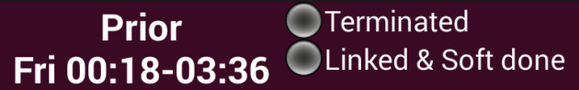If you are wearing your Zeo Headband and it is recording, but you walk away from your Android Device still wearing the headband for a significant distance and for about 5 minutes or longer, the Zeo App will “terminate” the sleep record. On the ZeoCompanion Sleep Journal, the status bar will show “Terminated” for the “ZeoRec” line.

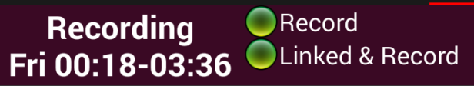However, *this situation is recoverable*. When you get close to the Android Device again, leave the headband on your head, and use your forefinger or thumb to press the button on the headband. The headband will automatically re-sync with the Zeo App, and the “terminated” sleep record will be re-activated. Wait about 2 or 3 seconds, then on the ZeoCompanion App, just change Sleep Journal Tabs (which will force the ZeoCompanion App to probe the Zeo App), and the ZeoCompanion App’s status bar will change to reflect the now re-activated sleep record. All events and attributes that are now entered will be placed inside this now re-activated sleep record.

**Headband comes off your head overnight while Recording**

For various reasons, the headband can either come off your head, or can slip and be misplaced on your head, while you are sleeping. 90% of the time, all you need to do is place the headband back onto your forehead at the proper location, and the headband will continue the overnight sleep record. Both the Zeo App and the ZeoCompanion App will not have “known” the headband stopped getting valid data, and will have continued their sleep records. You will however find a blank gap in the hypnograms where indeed the headband failed to be able to get a waveform signal.

However, occasionally, if the headband is left off one’s head for a long enough interval, the headband itself will close its sleep record even though it has not been docked on its charger. In that situation, when you put the headband back on while in-bed, the Zeo Headband and the Zeo App create a NEW sleep record. In the morning, you will find you have two sleep records from overnight, one for each portion and with a gap between while the headband was off your head. Your before-sleep attributes and initial events will be in the first sleep record; your after-sleep attributes and any final events can only be placed in the second sleep record.

Unfortunately, there is nothing the ZeoCompanion can do in this situation. The Zeo App has no facility to combine sleep records. And the ZeoCompanion App can only link to one Zeo App record. So you will indeed get these separated records in both the Zeo App and the ZeoCompanion App.

# Section III. Sleep Analysis

The ZeoCompanion App provides some **limited** capabilities for graphical statistical analysis of your recorded sleep sessions. The *STATS* tab on the main application display will show one or more recent-data charts depending upon the configuration of your settings. These recent-data charts on the *STATS* tab draw data from only the seven most-recent sleep sessions, and reflect therefore your most recent sleep experiences.

Version 1.1 offers only one chart type: Trends.

You can tap your finger on these recent-data charts which will bring up an expanded charting multi-tab display that draws from all your sleep session data and offers more graphing options. Each chart type is described in subsections below, and also describes the differences between the most-recent variant of the chart versus the expanded variant of the chart.

## Parameters Available For Analysis

For each sleep session, the Zeo App breaks down your total sleep session duration into various states, and sums them up in intervals of 30 seconds. Visually, these parameters are related to each other as follows:

Total Sleep Session Duration

REM

Time to Fall Asleep

Total Sleep

|  |
| --- |
| Unknown  Awake  Light  Deep |

Note that the Zeo App does not include the time it thinks you took to fall asleep into the Total Sleep summation (since it assumes this will be just a few minutes). The Zeo App similarly does not include times you woke up in the middle of the night to the Total Sleep summation (since ideally it should be zero). Thus the Total Sleep parameter is only the sum of the time in REM, Deep, and Light sleep. Unknown time can occur if the Zeo Headband slips off your forehead or otherwise stops recording during a portion of the Total Sleep Session Duration.

The following parameters are available for charting in the ZeoCompanion App.

|  |  |  |
| --- | --- | --- |
| **Parameter** | **Units** | **Based upon** |
| **Deep% Dur** | Percent | Deep sleep percentage of Total Sleep Session Duration |
| **Light% Dur** | Percent | Light sleep percentage of Total Sleep Session Duration |
| **REM% Dur** | Percent | REM sleep percentage of Total Sleep Session Duration |
| **Awake% Dur** | Percent | Awake percentage of Total Sleep Session Duration |
| **Time2Z% Dur** | Percent | Time-to-fall-asleep percentage of Total Sleep Session Duration |
| **Total% Goal** | Percent | Total Sleep percentage of goal for Total Sleep as configured in Settings->Profile |
| **ZQ** | Score | ZQ score; can span higher than 100 |

To make charting of multiple parameters possible on a single graph, the ZeoCompanion App’s graphs only show the Zeo App’s sleep session parameters as percentages. Thus the Y-axes of the graphs generally should not exceed 100%, however it is possible for the ZQ and Total% Goal parameters to be larger than 100%. Since Total Sleep as the Zeo App defines it is the sum of the REM, Deep, and Light parameters, it can be shown by activating those three parameters together. Therefore the ZeoCompanion App provides a different metric for Total Sleep%: it is the percentage of the stored goal for Total Sleep (rather than the percentage of the Total Sleep Session Duration) to offer a different perspective on sleep quality improvement.

## Trends Chart

The Trends chart allows you to visualize how one or more of the sleep parameters are changing over time. Hopefully if you are working to improve your sleep, these parameters will visually trend toward better indicators of your sleep quality over time. In particular, one would want to see upward trends in Deep, REM, and Total Sleep toward their goal lines.

The diagram below shows an example of the 7-session recent-data version of the Trends chart on the *STATS* tab, and various components of the graph.

|  |
| --- |
| Stats trends recent-data.png  **Single Parameter selection**  **Goal for the selected parameter (some parameters do not have goals)**  **Simple linear trend of the data over time**  **Line graph of selected parameter**  **X-Axis:  date interval**  **Y-Axis: percent** |

On the *STATS* tab, you can choose only one parameter at a time. Simply press a radio button to change to another parameter.

Only the start date and end date are ever shown for the seven sessions, but the spacing of the data points does reflect actual time spans and thus can include gaps (as seen in the above example) where some sleep sessions were not recorded.

To address persons with color blindness, note that in lieu of a “legend” on the graph and trying to use complicated line dashing and hashing, the lines are legend-labeled on the right-side of the graph. This is particularly important for the Expanded Trends chart. In some cases, those labels will overlap.

The Deep% and REM% goals can be changed in Settings->Profile, as can the goal for Total%. A Light% goal is computed as the remainder of 100% from the Deep% and REM% goals. ZQ, Awake%, and Time2Z% do not have goals.

The trend line is calculated using a simple least-squares linear regression. (<https://en.wikipedia.org/wiki/Linear_regression>) If you are not actively attempting to improve your sleep, the trend line likely will have little useful meaning.

**Expanded Trends Chart**

If you tap your finger on the 7-session recent-data chart, the ZeoCompanion App will invoke a more flexible graph that selects from all your recorded sleep sessions, allows you to show more than one parameter at the same time, is zoomable and scollable, and can switch between line-only graphs and mixed line/stacked-bar graphs. These graphs are only shown in landscape orientation.

|  |
| --- |
| Stats trends expanded 1.png  **Multiple trend lines past gaps in sleep recordings**  **Multiple Parameter selection**  **Choice of Lines-only or Lines + Stacked Bars**  **Choice of analysis tabs**  **Multiple trend lines past gaps in sleep recordings**  **Multiple trend line past gaps in sleep recordings**  **Multiple trend line past gaps in sleep recordings**  **Multiple trend lines past gaps in sleep recordings**  **X-Axis:  Full dataset timeline; zoomable and scrollable** |

Two key differences shown in the example graph above are utilization of the entire sleep session dataset, and the multiple trend lines. If a gap is sleep session recordings is greater than 7 days, then a new trend line is started so that the gap itself does not significantly distort the trend line. In the example graph above there are three gaps larger than 7 days, and thus four trend lines. One can also use the two-finger pinch gesture to zoom in and out the graph, then also use a one-finger scroll of the zoomed-in graph.

When two or more parameters are shown simultaneously as Lines-only, no trend nor goal lines are shown as the graph would become too complex with multiple sets of goal and trend lines. Shown in the graph below are the Deep% and REM% shown simultaneously. Note how the right-side legend-labels are set for each line. This type of multiple lines graph is rarely useful.

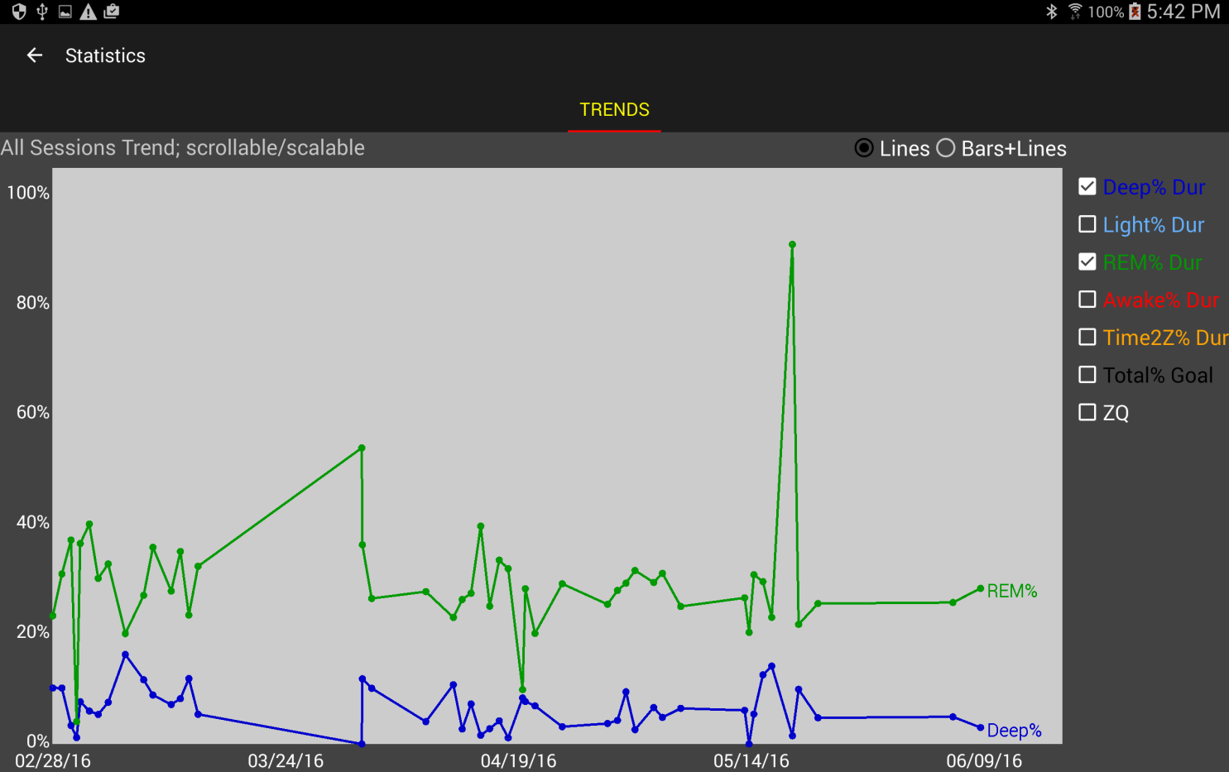

However, a Bars+Lines of the same two parameters is more useful, as shown below. An single additive goal line is shown. Trend lines of the additive sum of the two parameters is shown. The relative ratio of the one parameter versus the other can be seen at each date, and how they contribute to the total. As noted, three, four, more parameters can be simultaneously shown, though at times with little added meaningful effect. The right-side legend-labels are present at the top of each bar segment.

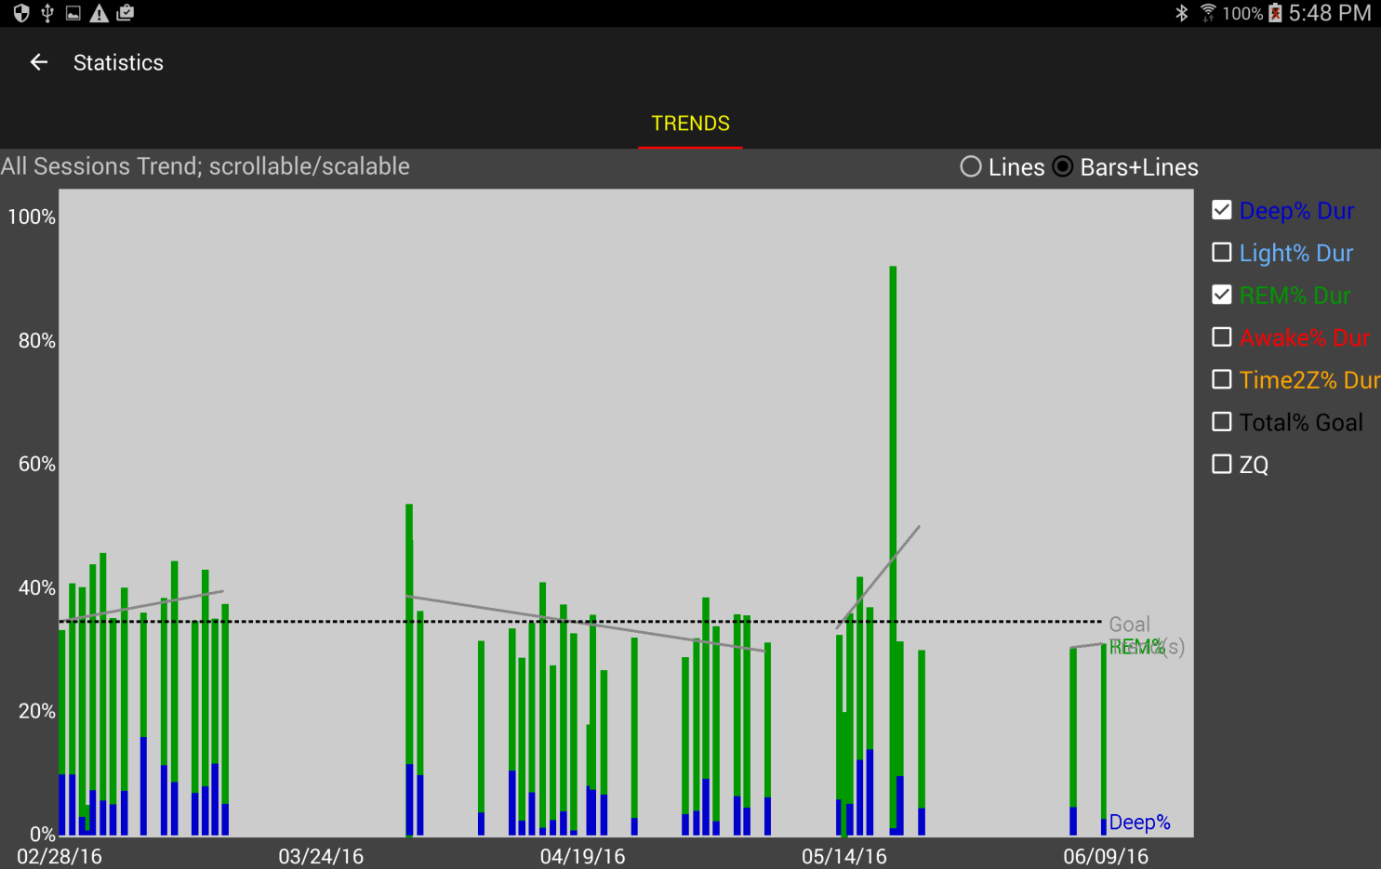

Because the ZQ and Total% Goal parameters are calculated in a different manner than the other parameters, even in Lines+Bars mode, those two parameters will always be shown as separate line graphs (will not be added into the stacked bars).

## Attribute Effects Chart

The Attribute Effects chart allows you to visualize how differences in your recorded Sleep Journal prior-to-sleep attributes are affecting your sleep quality. This chart is only shown if you have the Sleep Journal activated in the Settings->Journal. This chart will only be useful if you are deliberately experimenting with altering or tuning the values for selected attributes under your control, such as experimenting with the healthy sleep formula dosages, adjusting evening caffeine or alcohol quantities, adjusting bedroom temperature, etc.

Due to the inherent screen size and processing limitations of an Android device, the types of cause/effect analysis that can be performed on the ZeoCompanion App is very limited. In particular, studying the effects and optimal utility of two or more simultaneous attributes (for example, trying different dosages of Melatonin along with different dosages of L-Theanine and different bedroom temperatures) is simply not possible within the limited visual capabilities of the Android Device.

Assuming the guidance in Section V has been following regarding choosing proper Values for each Attribute, the left side of the graph will have Attribute Values that should degrade your sleep quality, and moving toward the right, Attribute Values that should improve your sleep quality. Therefore if you are actively experimenting with varying sleep factors (aka Attributes), and the trend line is sloped upward from left to right for a shown Attribute, then those right-most Attribute Values are indeed improving your sleep quality. If the trend line is flat, varying the shown Attribute apparently has no effect on your sleep quality.

Feature planned to be available in version 1.1.1

# Section IV. Exporting and Sharing

The ZeoCompanion provides the capability to export integrated information from the Zeo Application and the ZeoCompanion’s Sleep Journal. The exports take the format of comma-separated-value (CSV) files, or PNG image files. The Zeo API from the now defunct Zeo web site provided CSV columns for all the sleep attributes as well as the sleep session’s intervals and hypnograms. The ZeoCompanion’s exporter takes advantage of those additional columns for the Sleep Journal.

## Formats of Exportable Information

Some third-party Apps that you may try to import into require the sleep data to be expressed in 30-second epochs, others need minutes; some need spaces within the hypnograms, others do not; and of course if you are importing into Excel or a similar spreadsheet then minutes is more intuitive to end-users. The below list of exports indicates which time-interval the export utilizes, and the filename will include either “epochs” or “minutes” in the filename.

Currently the ZeoCompanion can export information for the following uses in the following formats:

|  |  |  |  |  |  |
| --- | --- | --- | --- | --- | --- |
| **Export name** | **Export type** | **Export data format** | **Useful for** | **Data content** | **Format specifics\*** |
| Image/ZeoApp | Image | PNG | Social Media | Zeo & Journal | (n/a) |
| CSV/SS/myZeo+/minutes | CSV | myZeo+ | Spreadsheet | Zeo & Journal | minutes spaces  number;text |
| CSV/ZeoViewer/myZeo+/minutes | CSV | myZeo+ | Zeo Data Viewer | Zeo & Journal | minutes  no spaces  number;text  alterStartOfNight |
| CSV/Sleepyhead/myZeo+/epochs | CSV | myZeo+ | Sleepyhead | Zeo & Journal | epochs  spaces;  number  alterStartOfNight |
| CSV/SS/ZeoRaw/epochs | CSV | ZeoDB | Spreadsheet | Zeo | epochs  no spaces; |
| CSV/SS/ZeoRaw+/epochs | CSV | ZeoDB | Spreadsheet | Zeo+ dead | epochs  no spaces |

\* 1st: minutes or epochs in sleep record, 2nd: spaces or no spaces in hypnograms,   
 3rd: number;text or number in attribute columns;   
 4th: start of night changed to be timestamp of 1st data point in both hypnograms

The name of the export file will contain information about its export use and export data format. If you have entered in a first name or other name in Settings->Profile, that name will also be included in the export file’s name.

## Image Export Example

The format of the image is structured similar to that which is produced by the Zeo App. However, this graphic annotates the hypnogram with any events that were entered overnight using the Sleep Journal.

The horizontal bars on the lower half of the image show whether the goal for that sleep stage was or was not reached. The “goal line” is the middle of each horizontal bar. The “Light Sleep” bar deliberately does not have a goal.

## Modes of Export

The ZeoCompanion offers the following modes to export information off of your Android device:

1. **Leave in Files**: the export file is created and stored in the device’s “external storage” area. This area could be on a SD card, or just storage “inside” your device depending on how you have configured your Android. It can also be accessed via USB from a personal computer, or be access from your Android device via a File Manager app. The default external storage directory path is: Android/data/opensource.zeocompanion/exports/  
   However you can use Settings->Export to change the destination to one of the following external storage directories: Documents, Downloads, or Pictures
2. **Share**: the export file is created, then passed to the Android OS’s “sharing” feature. A second “Share for…” Android dialog will appear with various Apps that can utilize the file if you have so configured those apps, such as Email, Dropbox, Drive, Facebook, etc. The ZeoCompanion App has no direct interaction with these Apps.
3. **Direct Email**: if you configure your email account into the ZeoCompanion, it can then directly email you the file without needing your interaction on the “Share for…” Android dialog. You can optionally setup automated daily export emails of your sleep sessions.

## Export Invocation

* **From the Main screen**, via the Sharing icon, which will allow you to choose the format of export, the data range to select from, and the mode of export.
* **From a History Detail screen**, via the Sharing icon, which will export just the one integrated sleep record. You still chose the format of export, and the mode of export.
* **Automatic email export** is configured in the Settings. You must configure both “Email” settings and “Auto-Email” settings. An email test feature is also available.

## Export Example

When you press the Share icon on the mail screen, you are presented with the following dialog:



D

C

B

A

**A:** Choose the Format of Export

**B:** Check the box to export all records. The date picker will disappear.

**C:** Otherwise choose a starting date for the records you want to export.

**D:** Press a button to choose the Mode of Export. If you press Share, the following dialog will appear next to allow you to choose an App for transporting the export:

## Direct Email Outbox (Manual or Automated exporting)

In cases where you are using the Direct Email feature (manual or automated) and the email fails to send for some reason, those failed emails are stored in the Email Outbox. You can invoke the Email Outbox from the main menu. If there are items in the Outbox, the yellow mailbox icon will appear in the App’s main menu area.

Each Outbox entry shows the date and time of the email attempt, the To address and Subject, then the error information that was provided to the ZeoCompanion App.



All the Outbox entries are stored in your Device’s “external storage”. So the export CSV files are accessible via SD card or USB cable as an alternative to RESENDING them. The Outbox’s path is: Android/data/opensource.zeocompanion/outbox/

If the failure to send was temporary (such as a down email server) or due to mis-configuration of your email settings, once corrected you can press the RESEND button.

If the failure was due to an incorrect To address, you can press the TOADDR button, and correct the To Address, then press the RESEND button.

If the email failure cannot be resolved, pressing the DELETE button will permanently remove the email from the Outbox.

## Expanded myZeo+ CSV file

The ZeoCompanion exports an expanded CSV file that builds upon the original export file from the now defunct myZeo.com website. This export file remains compatible with third-party software such as the Zeo Data Viewer and Sleepyhead.

Some columns are composed of “subfields” such as the pre-defined attribute columns which have a “**numeric-value;text-value**”. Using a spreadsheet, you can either leave these subfields intact by choosing only a comma as a separator, or you can place these subfields into separate columns by choosing a comma and a semi-colon as separators.

**Warning: Exported Dates and Times can be a bit tricky.** The Zeo Sleep Record’s “Sleep Graphs StartTime”, “Start-of-Night” and ”End-of-Night” originate from the clock inside the headband itself (and not the clock within the Android device). However, all ZeoCompanion event timestamps are based upon the Android device’s clock (including when it detects the Zeo App state changes). If the Headband’s clock is out-of-sync with the Android device’s clock, then attempting to relate the timings can be difficult. Likely because of this, the original myZeo export format did not include seconds within the “Start of Night” and “End of Night” fields in the export just to fuzz up these inaccuracies.

The Zeo App does make an attempt to correct for discrepancy between the Headband and Android clocks (shown in the Zeo App’s Settings->Diagnostics it’s the Clock Offset row in milliseconds). The Start of Night and End of Night are automatically timeshifted by the Clock Offset. However the Zeo App performs that offset calculation only once when it pairs with a new headband. If the Android time-of-day changes or drifts, or the Headband’s clock drifts, this offset will become incorrect over time**. However, you can tap the highlighted number in the Zeo App’s Clock Offset Diagnostic screen, and the Zeo App will poll the headband and recalculate a new up-to--date Clock Offset.**

The CSV structure is composed into sections. There are in general no delineators between sections; however column headers are provided in the first line of an export CSV file. Each section other than the first are optional, meaning they may or may not be present depending upon the actual data that has been input, end-user Settings, and version of the App.

1. Original myZeo columns

Feature planned to be available in version 1.2

1. Extended Zeo Sleep Record columns
2. Sleep Cycle Results columns
3. Amended Sleep Record columns (optional)
4. Free-format Sleep Journal columns (conditional)

**Original myZeo columns** – always present; see the still-available documentation for this at:  
https://www.gwern.net/docs/zeo/2013-zeo-exportdatasheet.pdf

|  |  |  |  |  |
| --- | --- | --- | --- | --- |
| **Category** | **Qty of columns** | **Column header** | **Units** | **Notes** |
| Date & Time | 1 | Sleep Date | Date | Date only |
| Sleep Record | 1 | ZQ |  |  |
| 1 | Total Z | Min or Epochs |  |
| 1 | Time to Z | Min or Epochs |  |
| 1 | Time in Wake | Min or Epochs |  |
| 1 | Time in REM | Min or Epochs |  |
| 1 | Time in Light | Min or Epochs |  |
| 1 | Time in Deep | Min or Epochs |  |
| 1 | Awakenings | Qty |  |
| Date & Time | 1 | Start of Night | Date/time | May include secs; this time will be within the first non-zero digit in only the Detailed Sleep Graph |
| 1 | End of Night | Date/time | May include secs |
| Alarms | 1 | Rise Time | Date/time | Only for Sleepyhead; same as End of Night |
| 1 | Alarm Reason |  | Not currently used |
| 1 | Snooze Time |  |
| 1 | Wake Tone |  |
| 1 | Wake Window |  |
| 1 | Alarm Type |  |
| 1 | First Alarm Ring |  |
| 1 | Last Alarm Ring |  |
| 1 | First Snooze Time |  |
| 1 | Last Snooze Time |  |
| 1 | Set Alarm Time |  |
| Attributes | 4 | (Morning/Day attributes) |  |  |
|  | 1 | Notes |  | Not currently used |
| Attributes | 26 | (Before sleep attributes) |  |  |
| Attributes | 21 | (Custom attributes) |  |  |
| Hypnograms | 1 | Sleep Graph | digit=5min | Spaces may be between entries |
| 1 | Detailed Sleep Graph | digit=30sec |
|  | 1 | Firmware version |  | Not used |
|  | 1 | myZeo version |  | ZeoCompanion version# |

**Extended Sleep Record columns** – additional information in the Zeo Sleep Records that were not exported in the original myZeo format.

|  |  |  |  |  |
| --- | --- | --- | --- | --- |
| **Category** | **Qty of columns** | **Column header** | **Units** | **Notes** |
| Hypnograms | 1 | Sleep Graphs StartTime | Date/time | Starts on a 5 min boundary; this is the start time of the 1st digit in both hypnograms |
| Date & Time | 1 | Start of Night Headband | Date/time | Headband clock’s Start of Night (can be used to calculate Clock Offset) |
| Headband | 1 | Battery Start of Night Highest | (unknown) |  |
| 1 | Battery End of Night Lowest | (unknown) |  |
| 1 | Impedance Start of Night | (unknown) | Not currently used |
| 1 | Impedance End of Night | (unknown) | Not currently used |
| Sleep Record | 1 | Light Changed to Deep | Min or Epochs | Subset of “Time in Deep” that headband tagged as between Light and Deep. |
| 1 | Deep Sum |  |  |

**Sleep Cycle Results columns**

Feature planned to be available in version 1.2

To-be-defined in version 1.1 of this App.

**Amended Sleep Record columns** – only present if enabled in Settings;  
These columns follow the prior sections.

|  |  |  |  |  |
| --- | --- | --- | --- | --- |
| **Category** | **Qty of columns** | **Column header** | **Units** | **Notes** |
| Sleep Record | 1 | Amend ZQ |  |  |
| 1 | Amend Total Z | Min or Epochs |  |
| 1 | Amend Time to Z | Min or Epochs |  |
| 1 | Amend Time in Wake | Min or Epochs |  |
| 1 | Amend Time in REM | Min or Epochs |  |
| 1 | Amend Time in Light | Min or Epochs |  |
| 1 | Amend Time in Deep | Min or Epochs |  |
| 1 | Amend Awakenings | Qty |  |
| 1 | Light Changed to Deep | Min or Epochs |  |
| 1 | Deep Sum |  |  |
| Hypnograms | 1 | Amend Sleep Graph |  |  |
| 1 | Amend Detailed Sleep Graph |  |  |

Depending on how you set the following two Settings->Journal Amending, information will be placed in either the Original myZeo section or the optional Amended Sleep Record section as follows:

|  |  |  |  |
| --- | --- | --- | --- |
| ***Export Include Amended Section*** | ***Export Place Amended 1st*** | **The baseline Zeo Sleep Record will be placed at** | **The Amended Sleep Record will be placed at** |
| No | No | Original myZeo section | \*not exported\* |
| No | Yes | * If the row has an Amended Sleep Record then the baseline Zeo Sleep Record is \*not exported\* * If row does not have an Amended Sleep Record, then baseline Zeo Sleep Record is placed at the Original myZeo section | Original myZeo section |
| Yes | No | Original myZeo section | Amended Sleep Record section; column headers have the prefix “Amend”. |
| Yes | Yes | Amended Sleep Record section; column headers have the prefix “Base” | Original myZeo section |

**Free-format Sleep Journal columns**  
These columns will always be placed at the end of the export past any other prior sections. There will be a variable number of columns for each sleep record row, and there are no header columns for this content in the first line of the export CSV file.

|  |  |  |  |
| --- | --- | --- | --- |
| **Category** | **Qty of columns** | **Column contains** | **Units** |
|  | 1 | “$ZeoCompJournalAddtl” |  |
| Attributes | 1 | “$A” |  |
| vari | (Custom Additional Attributes) |  |
| 1 | “$/A” |  |
| Events | 1 | “$E” |  |
| vari | (Events) |  |
| 1 | “$/E” |  |
|  | 1 | “$/ ZeoCompJournalAddtl” |  |

If there are no events to export, then no $E … $/E columns will be present. If there are no custom additional attributes to export, then no $A … $/A columns will be present. If there are neither events nor custom additional attributes present, then the entire section will be omitted.

**Sleep Journal Events**

Events are encoded as: “**timestamp;event;optional-text**”. The *timestamp* is formatted as “MM/dd/yyyy HH:mm:ss” in a 24 hour clock relative to your local timezone. The *optional-text* only appears for the two “doing something events” when In-bed or During-sleep. The *events* are:

|  |  |  |  |
| --- | --- | --- | --- |
| **Event text** | **Corresponds to** | | **Notes** |
| 1ToBed | In-Bed tab | GOT INTO BED |  |
| 1NotTry | In-Bed tab | (activity) | Has optional-text |
| 1ZeoStart | (automated) |  |  |
| 1ZeoRec | (automated) |  |  |
| 2Going | In-Bed tab | NOW TRYING TO SLEEP |  |
| 2Awake | Going to Sleep tab | PRESS IF STILL AWAKE |  |
| 3Wokeup | While Sleeping tab | WOKE UP |  |
| 3Doing | While Sleeping tab | (activity) | Has optional-text |
| 3Retry | While Sleeping tab | RETRYING TO SLEEP |  |
| 4Done | After Sleep tab | DONE SLEEPING |  |
| 4ZeoEnd | (automated) |  |  |

**Sleep Journal Custom Additional Attributes**

Most attributes are placed into the Original myZeo columns, including the 21 fixed custom columns. However, if you have defined even more attributes that do not fit into the 21 allocated custom columns, all extra entered attributes will be placed into the free-format area.

Free-format custom Attributes are encoded as: “**sleep-stage;attribute;numeric-value;text-value**”. The *sleep-stages* will only be 1 (Prior to Bed tab) or 16 (After Sleep tab). The *attribute*, *numeric-value*, and *text-value* will be whatever you have defined in the Customize screens (see Section IV).

# Section V. Customization and Settings

## Customization

There are two main types of customizable definitions.

* The “Doings” dataset allows you to choose the various activities shown in the *In-Bed* *and During Sleep* tabs of the journal.
* The “Attributes and Values” dataset allows you to chose what is shown in the *Prior to Sleep* and *After Sleep* journal tabs.

## Customize Attributes and Values

There are two types of Attributes: fixed pre-defined, and custom. The pre-defined attributes have fixed “slots” in the export record as defined by the Zeo website API. Twenty one custom attributes also have fixed “slots” in the export record, but you can add more custom attributes that will appear at the end of the export record.

Some tips about Values for the Attributes:

* It is usually quite difficult for most people to discriminate between fine subjective details between one choice and another. A lot of research has shown that a simple 3 to 5 item “Likert” scale is the most effective.
* A typical “Likert” scale has just three choices: Bad, Normal, Good with typical numeric values 1, 3, 5 respectively (or sometimes 2, 3, 4).
* A variant of that are binary decisions: No, Yes with typical numeric values of 1, 5 or 2, 4 (assuming that the Yes answer is more “good” than the No answer).
* An extended “Likert” would have 5 states such as: Terrible, Bad, Normal, Good, Excellent with numeric values 1, 2, 3, 4, 5.
* However, the ZeoCompanion App does not place any restrictions on the numeric value’s range. You could for example enter in supplement dosages in milligrams, and setup a few different values for the different dosage combinations you are trying.

Some tips about Attributes:

* The default list of Attributes as defined by the Zeo website API is far too long. Just like the Values, most people cannot discriminate between so many choices, and most do not want to think about and answer a 20 minute quiz before bed. You should turn off most of the Attributes, keeping only around 3 to 7 of the most significant Attributes that influence your sleep quality.
* The Prior to Sleep and After Sleep tabs provide a means to temporarily “show hidden” attributes, letting you select from time-to-time Attributes like Sickness that you likely rarely need.

When you pick the “Customize Attributes” menu item, the screen below will be invoked. Note that you can tab or swipe to get to the Custom Attributes & Values screen, or even swipe or tab to get to the Event Doings screen discussed in the next section.



D

C

B

A

**A:** This is a list of the pre-defined attributes from the Zeo website API. You cannot alter these attribute names, journal tabs, or export column names. Selecting a row will invoke the Values display (C) with the values configured for this attribute. The number before each attribute name is the “slot number” in the export data format.

**B:** These checkboxes allow you to show (checked) or hide (unchecked) the various attributes from the journal tabs. Therefore just uncheck those attributes that you are not interested in ever recording.

**C:** This is the Values display, which is always linked to the selected attribute. If you press the blue highlighted Value name or Value Numeric then an Edit Text dialog will appear (discussed below). You can also select the row for use with the Minus button.

**D:** Press the Plus button (+) to add a brand new Value. Press the Minus button (-) to delete the selected Value.

When you either press the Plus button or press the blue text Value entries, and Edit Text dialog will appear:



The Edit Text dialog lets you add or change the Value name, and lets you add or change the numeric quantity assigned to the value. When you generate an export, the numeric value is always included. You cannot leave either entry blank. And you cannot enter or change a Value name that duplicates one that already exists.

Working with the Custom Attributes tab is very similar to the above. You will note there are only two changes on the Custom Attributes and Values screen:

B

A

**A**: The Custom Attribute’s name is now blue highlighted, meaning you can press it to bring up an Edit Text dialog to change its name. The number before the attribute name is the slot# of the twenty-one fixed slot custom attributes in the export format.

**B**: The Plus button (+) will allow you to add a brand new custom attribute that will appear at the end of the export format. Those rows will not show a “slot#”. The Minus button (-) will allow you to delete one of those new non-slotted custom attributes. You cannot delete any of the twenty-one fixed slots, but you can hide them.

The Custom Attributes Edit Text dialog looks a bit different than the Values Edit Text dialog. 

You define the Attribute name as shown on the Android device plus a short “export column name” that will appear in the column headers of the export. You also choose whether this custom attribute appears in the Sleep Journal’s *Prior to Sleep* or *After Sleep* tabs. You cannot leave either text value blank. And the Attribute name cannot duplicate one that already exists.

## Customize Doing Events

Picking the “Customize Event Doings” menu item will invoke the following screen to allow you to add, delete, or alter events that are recorded on the *In Bed* or *After Sleep* tabs:



C

B

A

**A:** Provides a list of doing activities. Pressing on the row selects the row for use with the Minus button (in the example above “Gaming” is selected). Press on the blue highlighted text of the Doing name (regardless of whether the row is selected or not) to invoke the Edit Text dialog where you can change the name.

**B:** Provides check boxes that allow you to choose whether this activity appears on the *In-bed* and/or the *During Sleep* tabs of the journal. You can also select which one is shown by default (if more than one default checkbox is checked, the last-most in alphabetic order will be chosen as the default).

**C:** The Plus button (+) allows you to add a brand new Doing record. The Minus button (-) allows you to delete a selected Doing record.

## Customize the Order of Prior-to-Sleep Attributes

You can alter the order which the *Prior to Sleep* tab shows the long list of attributes. This ordering only affects the *Prior to Sleep* tab; export ordering is not changed.

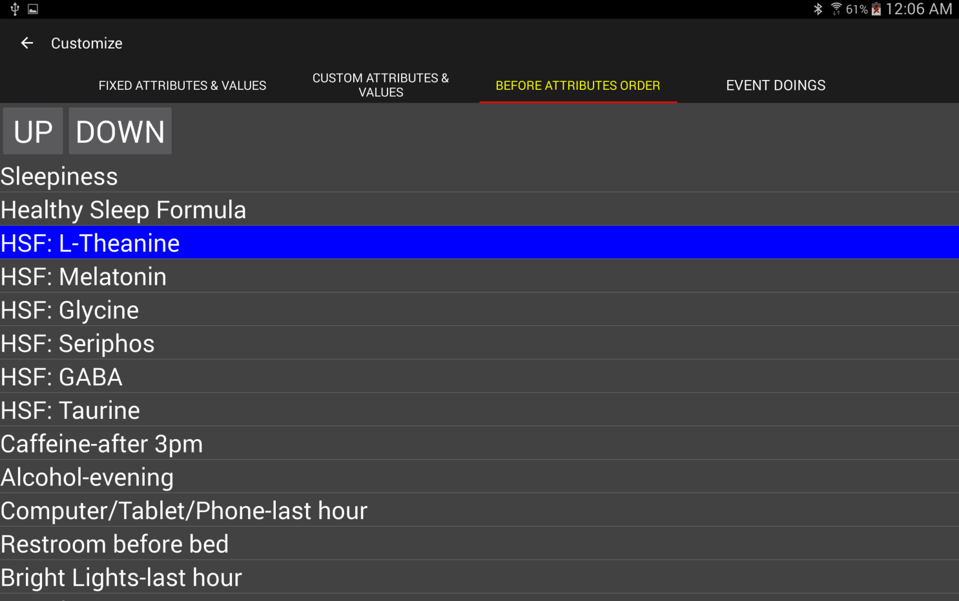

A

B

**A:** Select an attribute; it will be highlighted.

**B:** Press the UP button to move it up in the list; press the DOWN button to move it down in the list.

## Restore Factory Defaults

Choosing the “Restore Factory Defaults” option from the main menu and confirming the warning will reload all factory default attributes, values, and doings. All of your entered customizations will be permanently lost.

## Settings

The settings are organized into categories.

**Profile:**



Set your sleep goals: total hours of sleep, percent of Deep sleep, percent of REM sleep. These goals are used to color code information on the *History*, *History Detail*, and tabs. Also optionally set your first name (or other name as you like) that will be included in the names of your export files and backup database files (helpful if multiple persons in the same household are using Zeo Apps).

**History:**



You can choose which tab shows first when the ZeoCompanion App is first invoked. You can choose whether or not the white text details box shows on the *History* tab for each row. You can also choose the initial span of time first shown when the popup 30-second scrollable hypnogram is shown. To see more resolution (yet have to do more scrolling to see the entire hypnogram) choose a smaller time span. To see less resolution (and have to do less scrolling) choose a larger time span. In portrait orientation, on an Amazon Fire 7” or similar sized 600 x 1024 device, picking a value larger than 3.5 hours will result in bars less than one-pixel in width, and thus nothing shown in the 30-second popup hypnogram.

**Journal:**

**

You can choose to completely shut off the Sleep Journal. Or you can choose whether specific Sleep Journal tabs should show. You can turn off the notification sound made when the Zeo Headband fails to enter into Recording mode within 5 minutes of it being taken off its charger. And you can turn off the alert if the Zeo Headband’s clock appears out-of-sync with the Android device’s clock.

**Journal Amending:**

****

If you are using the Sleep Journal events feature to amend the Zeo’s sleep records, you can choose whether the History Tab and the History Details screen show first the unamended Zeo sleep records, or the amended ZeoCompanion sleep records. In either case, you can always switch between the two using the Show Amended checked on those screens.

For exporting, you can choose whether the CSV export contains both the unamended and amended data (in separate columns) [otherwise only one set of sleep data columns will be present). Separately you can choose whether the primary (and perhaps only) sleep data columns has the amended data [else will have the unamended data].

**Export:**

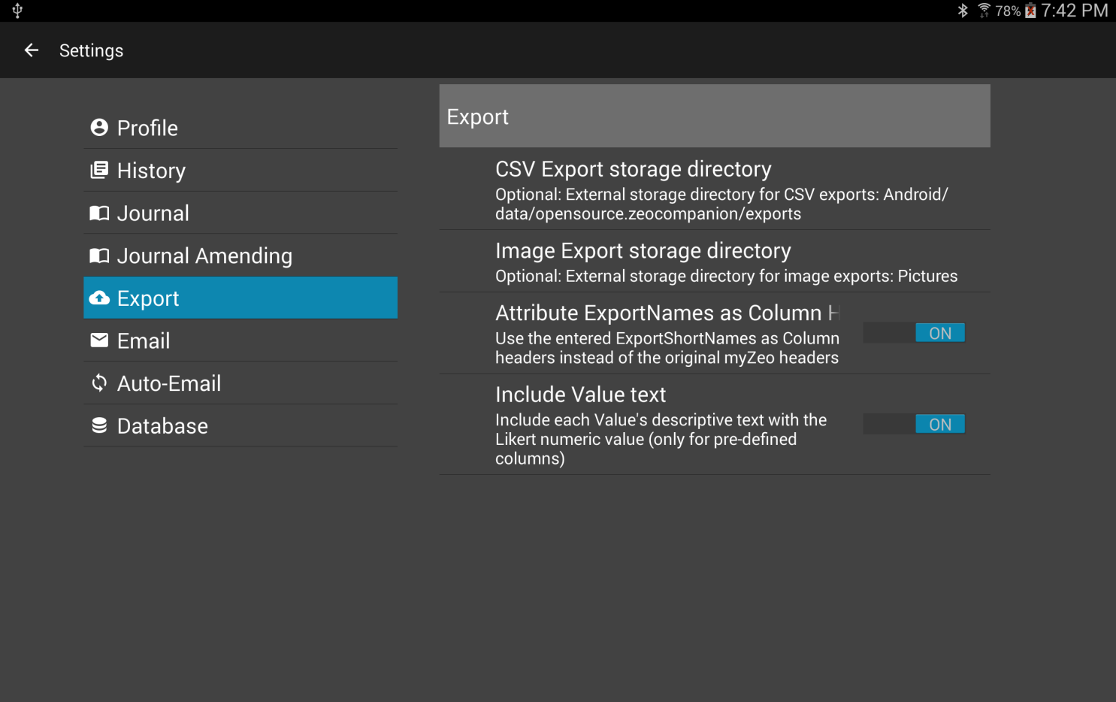

You can choose which directory to store either an image export or a CSV export. By default they are stored in the App’s external storage directory. However, you can change that to the Documents, Downloads, or Pictures external storage directory.

You can also choose whether to use the original Zeo website API column header titles, or whether to substitute in the ones you’ve defined for the Custom Attributes. You can also choose whether the fixed slots in the Zeo website API for the attributes contains just the numeric value, or both the numeric and textual values. If both are selected, they are stored as “number;text” using a semi-colon as the delimiter.

**Email:**

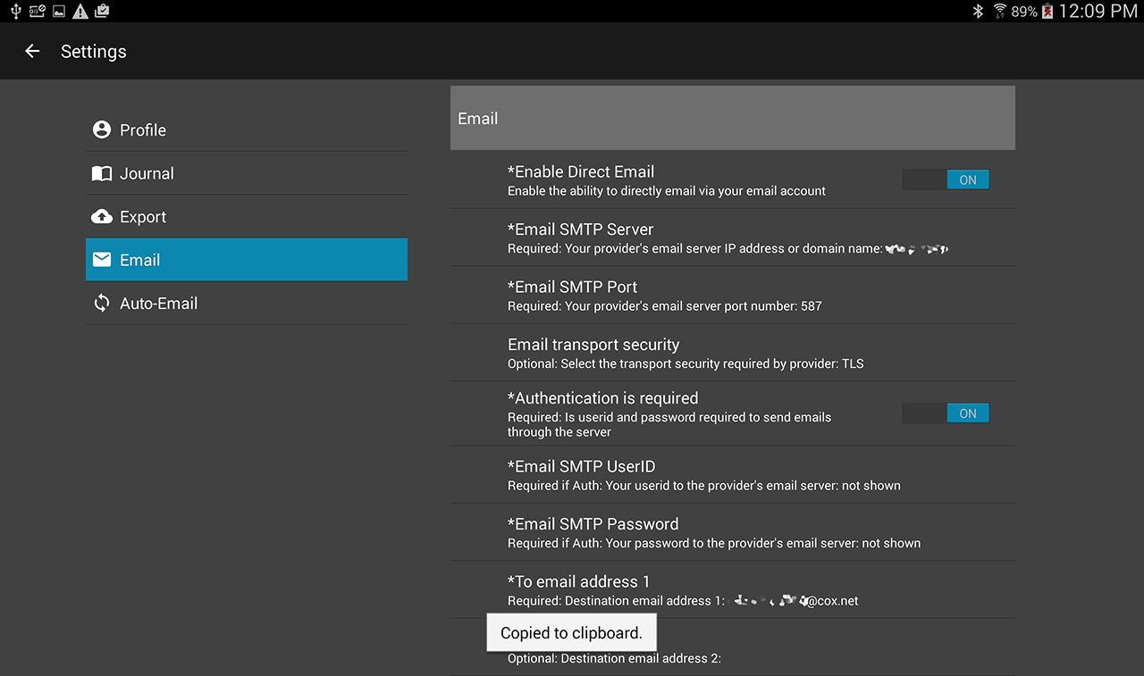

In order to utilize the optional Direct Email mechanism instead of the Android Sharing mechanism, you must configure in a SMTP server that you are allowed to send email through. If you have already configured one into another Android email App, you must re-enter it here. First choose Enable Direct Email. Then enter your SMTP server address and port number. Choose whether to use TLS, SLL, or none. Toggle on Authentication Required if so required, then enter your userid and password for accessing the SMTP server. Then enter in at least one destination email address to receive your exports.

At the bottom there is a TEST NOW button, and when pressed the ZeoCompanion App will attempt to send a test email to the destinations you have configured. If any of the destination emails fail, they will be shown as alerts on the screen. If they all succeed, you will get a brief popup message toward the bottom of the screen.

**A note about security for your settings.** More recent versions of Android provide whole disk encryption to protect everything, including these email account settings. Earlier versions provide no protection and no secure storage. The ZeoCompanion App utilizes an industry common technique to store these email settings in an encrypted form. However, the unique per-device keys to the encryption are within your Android device and are easily recovered by a skilled technician with physical access to your device. So at best the ZeoCompanion App is obscuring your settings, but not truly protecting your settings. Please use a “low value” unimportant email account for sending Direct Emails.

**Automatic Email of Daily Exports and Database Backups:**

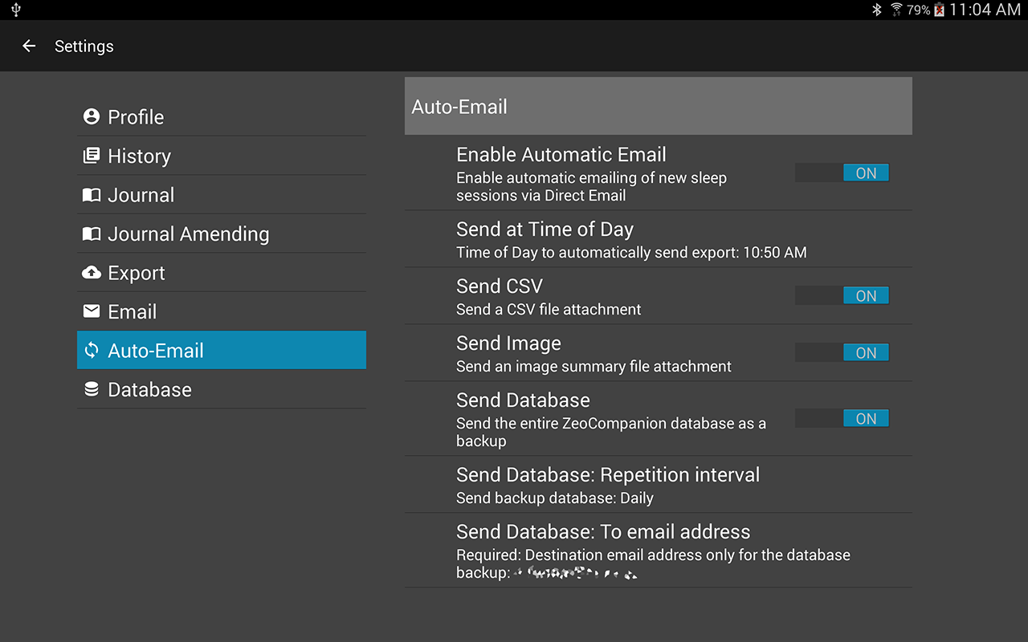

You can optionally have the ZeoCompanion App email you a daily export of your last night’s sleep session. You must first successfully configure the Direct Email settings. Choose Enable Automatic Email on the enable this feature. Set a time-of-day to automatically send the sleep results (perhaps in the later morning). You can choose to send a CSV, and Image Summary, or both.

You can additionally configure to email a backup copy of your ZeoCompanion database. You can send that backup daily or weekly. You must configure one specific to-email-address that will be used to receive the backup (the three possible to-email-addresses in the Settings->Email will not be utilized for a database backup).

**Database Replication**



You can choose to replicate the Zeo App’s data within the ZeoCompanion’s database. This is wasteful of your Device’s RAM. However, this can be useful in several ways:

1. The Replicated data is included with the rest of the ZeoCompanion database, which you can back-up using the ZeoCompanion DB Backup menu item discussed in Section V. The Zeo App itself does not offer a way to backup its database individually.
2. You can move the ZeoCompanion database that has replicated Zeo App data to another Android Device that has the ZeoCompanion App installed, and even the Zeo App installed. If you have been unable to move the Zeo App and its data to the new Device, using the backup and restore described in Section V with the ZeoCompanion plus Zeo App Replicated data will effectively move all your Zeo App data to the new device (though that history data will only be seen in the ZeoCompanion App). Then you can use the Zeo App to record new sleep sessions, and on the Zeo Companion App you will have both “old” and “new” history available.

Feature #2 planned to be available in version 1.2

1. It can assist the Developers of the ZeoCompanion App to have a database emailed to them that contains all the data needed to debug an issue with the App.

The PURGE COPY button can be used to remove or re-generate this duplicated Zeo App data in the ZeoCompanion’s database. **Note: The ZeoCompanion App cannot and will not purge any data from the Zeo App itself.**  You will be asked to confirm the purge before proceeding.

To purge all the copied Zeo data, first set the “Replicate Zeo Database” option to off, then press the PURGE COPY button. To regenerate the replication, leave the “Replicate Zeo Database” setting on, and press the PURGE COPY button.

**WARNING**: If you do have copied sleep records from the Zeo App in the ZeoCompanion’s database, and those sleep records are no longer in the Zeo App (perhaps because you moved sleep records from one device to another), then performing this purge will permanently lose those sleep records that are no longer in the Zeo App.

# Section VI. Extras

## ZeoCompanion DB Backup

The ZeoCompanion’s database can be copied into the Android Device’s “external storage”, **then moved to a personal computer for backup purposes**. This database can be restored into the ZeoCompanion App as described in the next section. The database backup can also be opened on your personal computer with a database tool that understands SQLite databases. It is also possible that Apps that can read the Zeo App database can also read the ZeoCompanion App’s database when replication of the Zeo App data is enabled.

Pressing the “ZeoCompanion DB Backup” menu item will copy the database by default to external storage in: Android/data/opensource.zeocompanion/internals/  
If you have entered in a first name or other name in Settings->Profile, that name will be included in the backup file’s name.

You can also use Settings->Database to change the external storage folder for the backups to either “Backups/ZeoCompanion” or “Documents”. Choosing one of these two other folders normally will preserve the database backup files even upon uninstalling the ZeoCompanion App. However, it is very bad practice to rely upon keeping these backup files on the Device. Please implement an Android-wide backup mechanism, or an App backup mechanism, or use the USB cable to move the database backup file off the Device. You can also use Settings->Auto-Email to email yourself a copy of the backup database either daily or weekly.

Please note that by default the backup is only the ZeoCompanion’s database. It is not the Zeo Application’s database. **However, if you have turned on “Replicate Zeo Database” in the Settings, the ZeoCompanion database will have a copy of the Zeo App’s database which will then be included in the overall database backupfile.**

## ZeoCompanion DB Restore

The command (if confirmed) will completely wipe out your existing ZeoCompanion database on this device, and install a previously backed up ZeoCompanion database. You will first be given a dialog in which you can choose which database file to restore. Then the App will check whether that database is restorable or not; if not you’ll be given an error message. If the database is restorable, you will be given a final Confirmation dialog to proceed or cancel.

If you have set a Settings->Profile name, and the database-to-restore also has a name (which is stored internally), they must be identical.

The database to-be-restored must be in external storage on your Android device in whichever folder you have chosen in Settings->Database. By default this directory path is:  
Android/data/opensource.zeocompanion/internals/

The normal reason to perform this action would be to move your ZeoCompanion database from one Android device to a new device. After a restore, some screens may still hold information from the prior database, but should re-organize themselves as you move from tab to tab.

If the database to-be-restore also contains replicated Zeo App database records, then those records become available to the ZeoCompanion App in addition to all those stored within the Zeo App’s own database. Note that the ZeoCompanion App CANNOT add, replace, or delete any of the records in the Zeo App’s own database.

## ZeoCompanion Alerts

When there are situations that occurred during automated operations, alerts can get generated and stored. These alerts are accessible via the Alerts menu item. If there are any alerts, the yellow alert icon will show in the Main Window’s menu area. This will bring up a dialog where you can read and delete the alerts. Once all alerts are deleted, the yellow icon will go away. Alerts are generally only created by automatic email failures, Zeo database replication failures, and application aborts.



## ZeoCompanion Error Log file

Current versions of Android prevent end-users to access the hidden internal “logcat” error log file. This file is highly useful for debugging, but unless an end-user has an Android Debugger installed or has rooted their Android device, it cannot be accessed. The ZeoCompanion does try to intercept its own aborts, as well as intercept critical database errors. When these are captured, they are stored in external storage at: Android/data/opensource.zeocompanion/internals/error.log

An alert will also be posted to inform you errors are available and should be sent to the Developer. You can delete this file at any time if it grows too big or if you’ve emailed it successfully to the Developer.

As a convenience, if this error.log does exist, in the Main Menu an “Email error.log” option will become visible. When selected you will be able to choose your email program, then an email will be automatically started with the error.log attached plus the proper To Address and Subject filled out. Just add a description of the problem you are experiencing and send it. Then you can delete the error.log file if you wish.

## Headband Commander

There is a menu item for the “Headband Commander”. If you accept all the warnings, and invoke the tool, the ZeoCompanion App can be directly connected to the Zeo Headband, receiving its sleep broadcasts, and able to send commands to the headband.

However, due to limitations in both Android and the Zeo Headband, only one app at a time may connect to the Zeo Headband. In order for the ZeoCompanion App to connect to the Zeo Headband, you will have to use the Android Applications Manager to “Force Stop” the Zeo Application. Then the ZeoCompanion App can make a connection. Every time the headband disconnects from the ZeoCompanion App, the Zeo App gets automatically invoked and reconnects to the headband. So one must constantly Force Stop the Zeo App.

The Headband Commander can send commands to the Zeo Headband. Many of these commands are useful. Some commands can brick your headband and make it permanently unusable.

**Therefore use this feature only at your sole risk and sole responsibility. Mess up, and you have no one to blame but yourself for using this feature.**

However, this feature can be used to reset or reboot a headband, and explore how to invoke the Zeo Headband’s test mode to gain access to the waveform.

The Headband Command has a very simple GUI. Once you Force Stop the Zeo App, press the CONNECT button on the GUI, then press the button on the top of the Zeo Headband. The headband should immediately connect to the Commander, and the headband’s name and MAC address will be shown.

You should immediately get a headband “sleep record” transmitted from the headband to the app even though no sleep session is underway. If you put on the headband, you’ll see various messages from the headband as it progresses from starting to recording mode. Then the headband will send updated “sleep records” about every 5 minutes.

You can use the SEND button to send commands and inquiries to the headband. The safest Commands are “Request State Report” and “Request Sleep Report”. Using any other command could cause issues with your headband, and numerous of the commands have NOT been tested for their actual effects on the headband.

A Time Query can reset the headband’s internal clock, but most times it does not.

The Test messages are dangerous. Some will force your headband to disconnect and perhaps get the red blinking LED. The only safe ones are TEST LED ON=true and TEST LED ON=false. These two commands will control whether the headband’s LED is continuously illuminated when the headband is on your forehead.